**The UDP Bandmap**

Aki Yoshida JA1NLX

## 1. 0 GENERAL

## 5.0 MENU

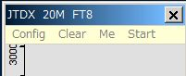

UBM\_6A

## 5.1 Config

Select the Config menu item.

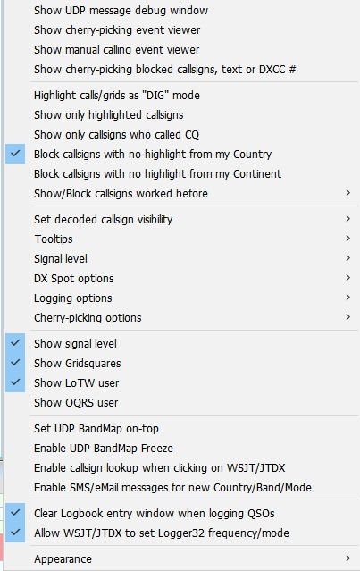

New UBM\_6AB

There are a lots of options. You may choose whatever you prefer now.

If you want to see highlight colors and tooltips information based on every mode then un-check "Highlight callsigns as "DIG" mode" This option works for displaying "QSOd B4" mark as well.

If you want to set the Logger32 frequency/mode from WSJT-X/JTDX then check “Allow WSJT/JTDX to set frequency/mode” Logger32 radio port must be closed. See paragraph 5.4 Start for related explanation and paragraph 5.0 Band Mode Selection Setup in the Logbook Emtry topic.

If you want to see the Gridsquare then check "Show Gridsquares".

If you want callsign lookup when clicking directly on WSJT/JTDX then check “Enable callsign lookup when clicking on WSJT/JTDX”.

If you want to send an SMS/eMail message then setup DX spot alerts (eMail/SMS/ScratchPad) in the DX spot window, then check “Enable SMS/eMail message for new Country/Band/Mode”. Messages are sent once for each new Country/Band/Mode. if the Country is decoded again after 15 minutes, another message is sent. On the DX SPOT ALERT SETUP all checkboxes are ignored except the “CHECK THIS IF YOUR EMAIL ALERTS ARE BEING BLOCKED AS SPAM”

(See DX spot section in this Help).

Sample message below.

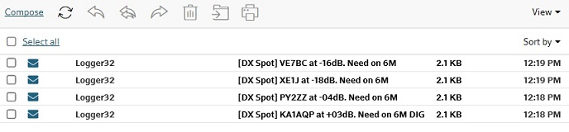

UBM\_6AB1

### Sub menu for Logging options



UBM\_6AC

The UDP Logging requests.txt file logs every QSO logging request received from the WSJT/JTDX UDP. This file is created in the \Logger32 directory and erased every time Logger32 starts.



UBM\_6AD

If you want to use direct logging then check “Allow automatic WSJT/JTDX QSO logging”. When “WSJT-X Automatic logging (no mouse clicks)” is enabled, this will automagically close the insanely annoying WSJT-X logging window. The first time you are prompted after starting WSJT-X, Logger32 will close it for you in under 5 seconds (you can close it manually if you like). After that, Logger32 will close in less than 500ms.

The VFO frequency plus receive tone frequency are written in the ADIF FREQ\_RX field in the Logbook. Logger32 calculates and logs the ADIF DISTANCE field. Look at logged QSO with below. Gridsquare and Distance are logged only if there are decoded.

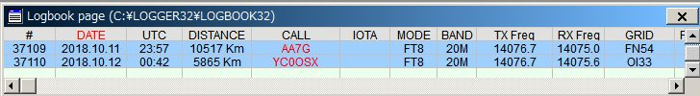

UBM\_6B

When “Log additional info from Logbook Entry Window” is checked, the following data entered into the Logbook Entry Window is logged with the UDP logging information if not already in the UDP logging message.

TX\_PWR, QTH, ADDRESS, COMMENT, NAME, STATE, and CNTY.

If you want to set the Logger32 frequency/mode from WSJT-X/JTDX then check “Allow WSJT/JTDX to set frequency/mode” Logger32 radio port must be closed. See paragraph 5.4 Start for related explanation and paragraph 5.0 Band Mode Selection Setup in the [Logbook Entry Window](#_topic_LogbookEntryWindow) section.

### Sub menu for Signal level

If you want to see the signal level then check "Show signal level" and click ”Signal level” to select the signal level type, SNR or S units.

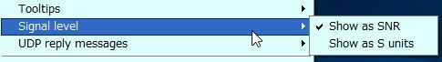

UBM\_6C

If you want to see the Gridsquare then check "Show Gridsquares".

### Sub menu for “DX Spot options”

### If you want to send DX spot from UDP BandMap then select either of these options and check “Show Gridsquares” option. Right click on gridsquare or place where gridsquare is displayed. See sample DX spot below (UBM\_6C2)

UBM_6C1

UBM\_6C1

UBM_6C2

UBM\_6C2

### Sub menu for “Show/Block callsigns worked before”

If you want to block callsigns QSOd this band/mode B4 then check like this.

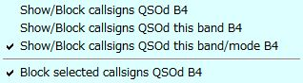

UBM\_6D

## Sub menu for "Set decoded callsign visibility"